Steps to build a PC using Intune

- Order the laptop/desktop through a VAR or direct from the OEM. Ensure the VAR/OEM either provides the hardware ID in a CSV file for upload into Intune, or that the VAR/OEM injects the hardware ID’s into Intune for you
- If the hardware ID is not already in Intune, and is not provided by the VAR/OEM, run the PowerShell scripts on the Windows 10 machine.
  - If booting from the OOBE, use these steps:
    - Turn on the PC and wait for the OOBE to start. Do not proceed through any of the OOBE steps.
    - Ensure there is a network cable plugged in and the PC has Internet connectivity.
    - If only Wi-Fi is available, proceed through the OOBE steps only up until the Wi-Fi setup. Once you have Wi-Fi Internet connectivity do not proceed with any further OOBE steps and proceed to the next step in these directions.
    - Press and hold the “Shift” key and press “F10”. This will get you to a CMD prompt
    - At the CMD prompt, type the command “PowerShell” and press enter
    - Execute the command “Set-ExecutionPolicy -ExecutionPolicy Unrestricted”
    - Execute the command “Install-Script -Name Upload-WindowsAutopilotDeviceInfo”
      - Answer “Yes” or “Y” to all the questions that follow
    - Execute the following command “Upload-WindowsAutopilotDeviceInfo.ps1 -TenantName "%tenantname%.onmicrosoft.com" (where "%tenantname% is your tenant’s name)
    - The PowerShell will prompt you to authenticate. You need to be a Global Admin or an Intune Service Admin for this step.
    - When the script is successful, results like the following will be displayed:
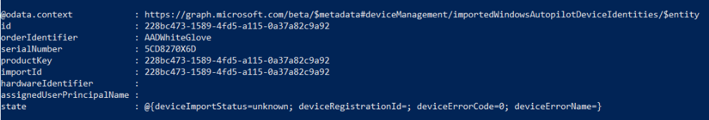
    - Power off the PC
  - If performing the process on a machine that’s already in use but not in Intune, use these steps:
    - Login to the Windows 10 machine using an admin account
    - Ensure there is Internet connectivity to the PC
    - Launch a PowerShell window as an administrator
    - Execute the command “Set-ExecutionPolicy -ExecutionPolicy Unrestricted”
    - Execute the command “Install-Script -Name Upload-WindowsAutopilotDeviceInfo”
      - Answer “Yes” or “Y” to all the questions that follow
    - Execute the following command “Upload-WindowsAutopilotDeviceInfo.ps1 -TenantName "%tenantname%.onmicrosoft.com" (where "%tenantname% is your tenant’s name)
    - The PowerShell will prompt you to authenticate. You need to be a Global Admin or an Intune Service Admin for this step.
    - When the script is successful, results like the following will be displayed:

  - Power off the PC
- Login to Intune (https://portal.azure.com) and add the device to the appropriate device security group
  - i.e. SG-IAP-City
- If you know who the PC will be assigned to, assign the intended user to the machine. (If you do not know who it will be assigned to, you can stop at this point and put the PC in storage, but make sure you label the machine, so you know what state it is in.)
  - Go to the Intune “Windows Autopilot Devices” blade to assign a user
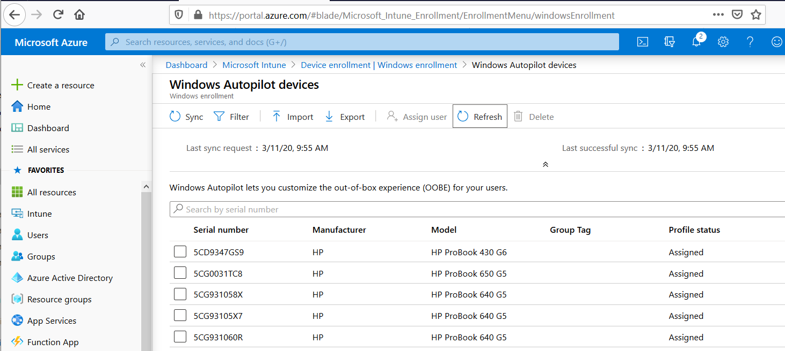
  - Click the box next to the machine you need to assign.
  - Click the “Assign user” option on the menu
  - Type in the users’ name into the “Select” box, then click on the users’ name to select them, and then click on the “Select” button to assign the user to the computer.
  - IMPORTANT STEP: Ensure that the “Profile status” on this screen shows “Assigned”. You cannot use this machine until the profile status reaches the “Assigned” state. If you have any issues, contact Imperitiv Support.
- At this point, you can issue the computer to the user. Have them plug in power, attach a network cable (unless using Wi-Fi) and turn on the PC. When the OOBE experience comes up with an ethernet connection, they should be able to flow through the steps and be prompted by name to login to the Path Interactive Azure AD instance. If they are on Wi-Fi, they’ll need to flow through the OOBE process and configure their Wi-Fi connection before being prompted to login with their Path Interactive Account.

